**CS 323 Homework 3**

1. Show these 5 nodes (x, tanh(x)) (5 pts)

$x_{0}=-2,\tanh\left(x_{0}\right)=\frac{\exp\left(-2\right)-\exp\left(2\right)}{\exp\left(-2\right)+\exp\left(2\right)}=-0.964$

$x_{1}=-1,\tanh\left(x_{1}\right)=\frac{\exp\left(-1\right)-\exp\left(1\right)}{\exp\left(-1\right)+\exp\left(1\right)}=-0.762$

$x_{2}=0,\tanh\left(x_{2}\right)=\frac{\exp\left(0\right)-\exp\left(0\right)}{\exp\left(0\right)+\exp\left(0\right)}=0$

$x_{3}=1,\tanh\left(x_{3}\right)=\frac{\exp\left(1\right)-\exp\left(-1\right)}{\exp\left(1\right)+\exp\left(-1\right)}=0.762$

$x_{4}=2,\tanh\left(x_{4}\right)=\frac{\exp\left(2\right)-\exp\left(-2\right)}{\exp\left(2\right)+\exp\left(-2\right)}=0.964$

1. Use these 5 nodes as given data to form the Van der Monde matrix (10 pts.) and find a polynomial to interpolate these 5 nodes (10 pts). The specific procedure of formulating the Van der Monde Matrix is required.
   1. 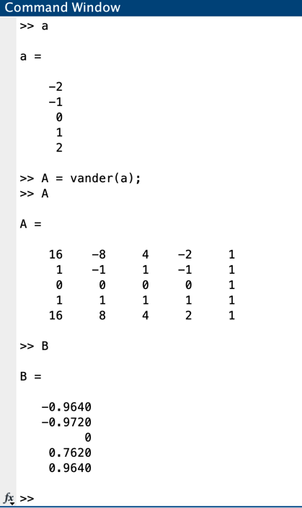
   2. polynomials = $-(x∙(140∙x^{2}-1283))/1500$
2. Write down the cardinal functions for these 5 nodes (20 pts), and use the Lagrange polynomials to interpolate these 5 nodes, show the polynomial (15 pts).
   1. 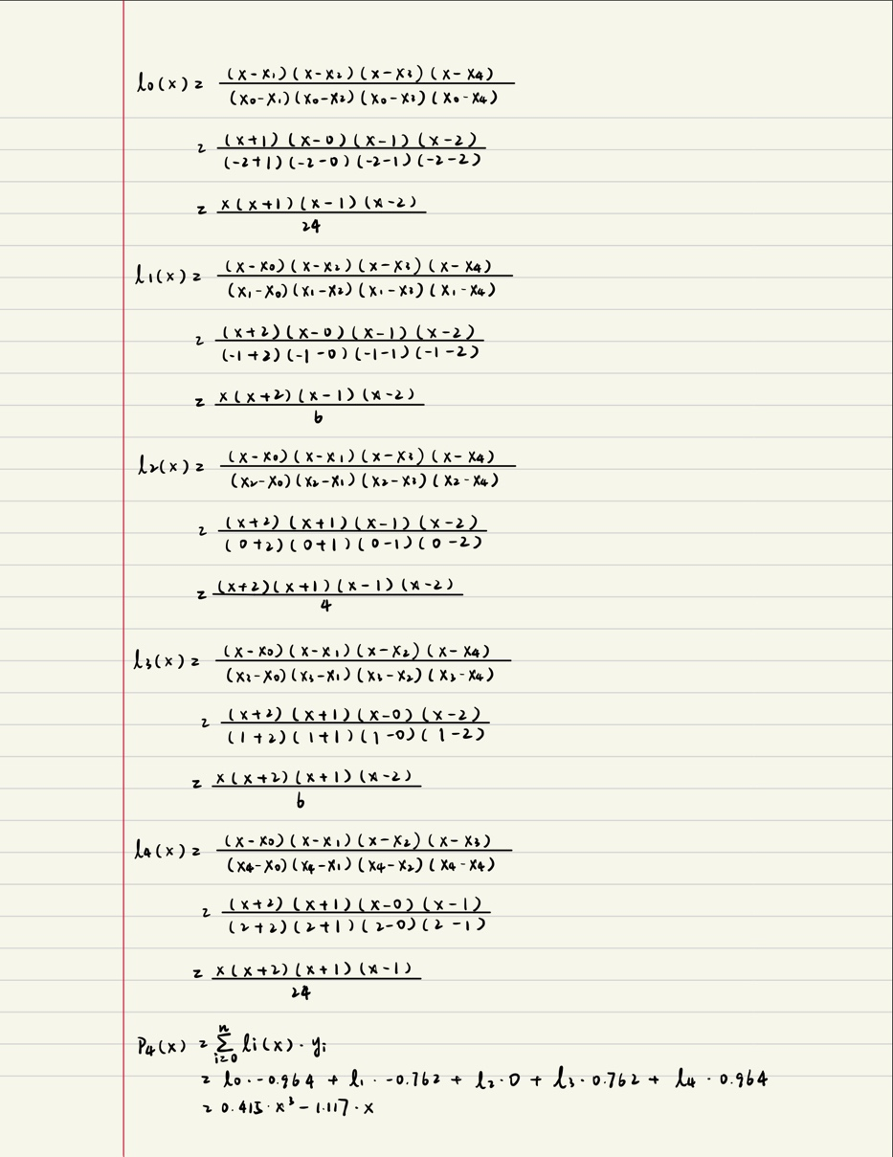
   2. Polynomial = $0.415∙x^{3}-1.117∙x$

1. Based on these 5 nodes, use linear spline function to approximate f(x) = tanh(x), x ∈ [−2,2] (25 pts). The specific liner splines for each sub- interval are required.
   1. 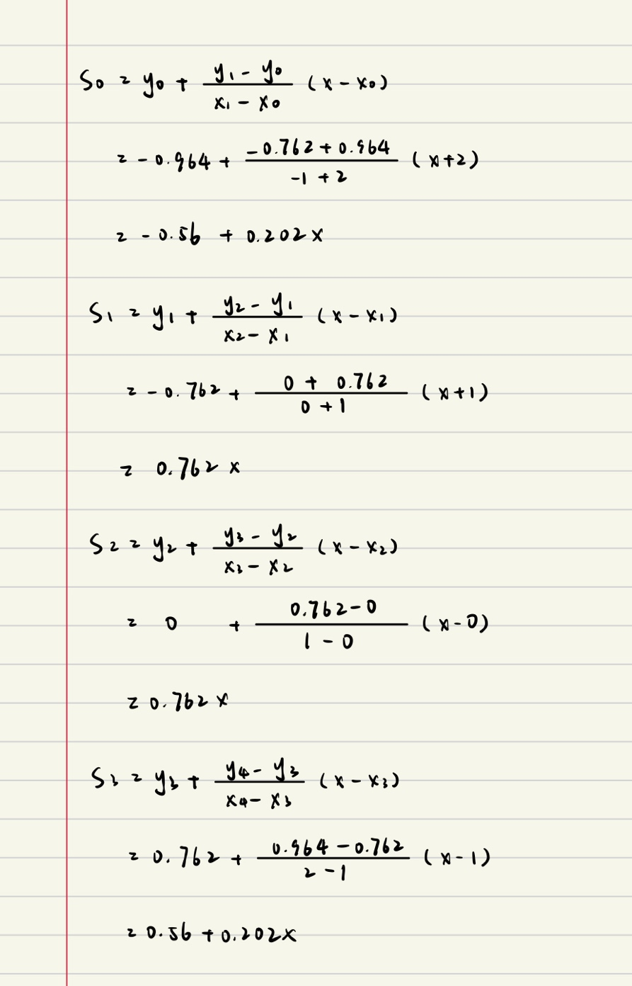
2. Based on these 5 nodes, use cubic spline function to approximate f(x) = tanh(x), x ∈ [−2,2] (25 pts). The specific cubic splines for each sub- interval are required.

